What is Cloud?

What is Cloud?

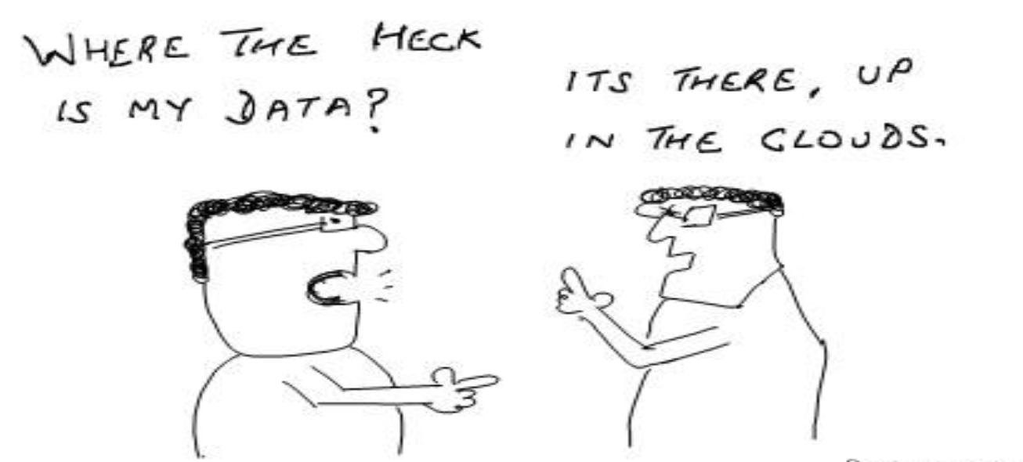

Cloud Computing is a general term used to describe a new class of network based computing that takes place over the Internet.

A collection/group of integrated and networked hardware, software and Internet infrastructure (called a platform).

Using the Internet for communication and transport provides hardware, software and networking services to clients.

These platforms hide the complexity and details of the underlying infrastructure from users and applications by providing very simple graphical interface or API (Applications Programming Interface).

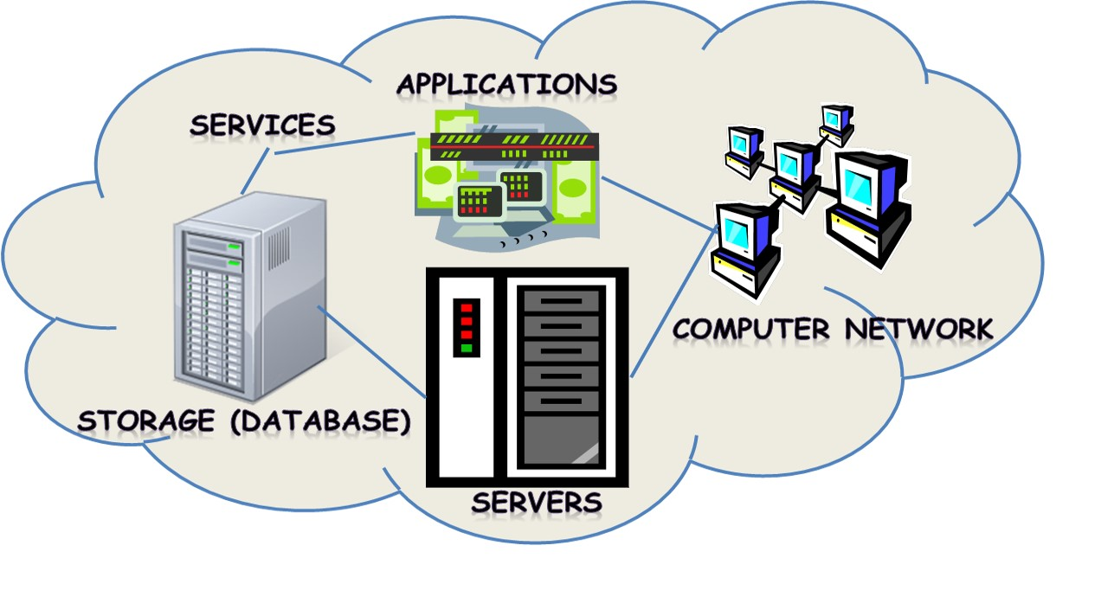
- Shared pool of configurable computing resources.
- On-demand network access.
- Provisioned by the Service Provider.

What is Cloud?

In addition, the platform provides on demand services, that are always on, anywhere, anytime and any place.

Pay for use and as needed, elastic scale up and down in capacity and functionalities.

The hardware and software services are available to general public, enterprises, corporations and businesses markets.

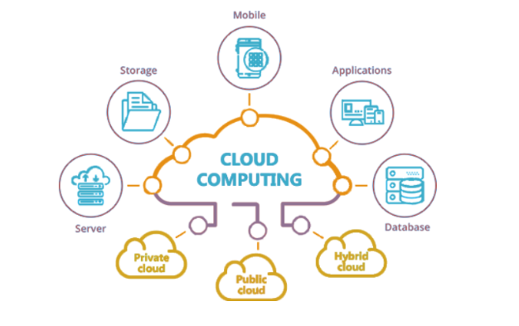

Cloud computing is an umbrella term used to refer to Internet based development and services.

A number of characteristics define cloud data, applications services and infrastructure:

- Remotely hosted: Services or data are hosted on remote infrastructure.
- Ubiquitous: Services or data are available from anywhere.
- Commoditized: The result is a utility computing model similar to traditional that of traditional utilities.

https://www.youtube.com/watch?v=n9i52Eu-Ivs&feature=emb_imp_woyt

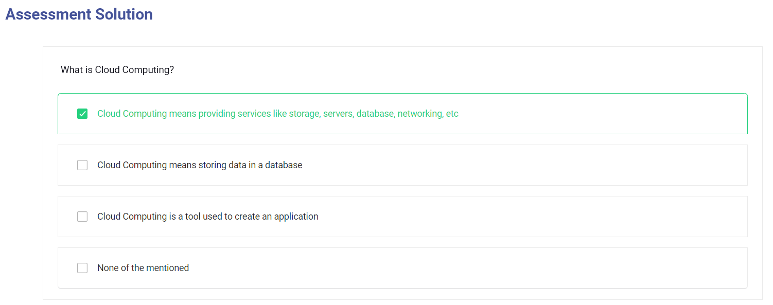

How does cloud computing work?

How does cloud computing work?
Rather than owning their own computing infrastructure or data centres, companies can rent access to anything from applications to storage from a cloud service provider.
One benefit of using cloud-computing services is that firms can avoid the upfront cost and complexity of owning and maintaining their own IT infrastructure, and instead simply pay for what they use, when they use it.
In turn, providers of cloud-computing services can benefit from significant economies of scale by delivering the same services to a wide range of customers.
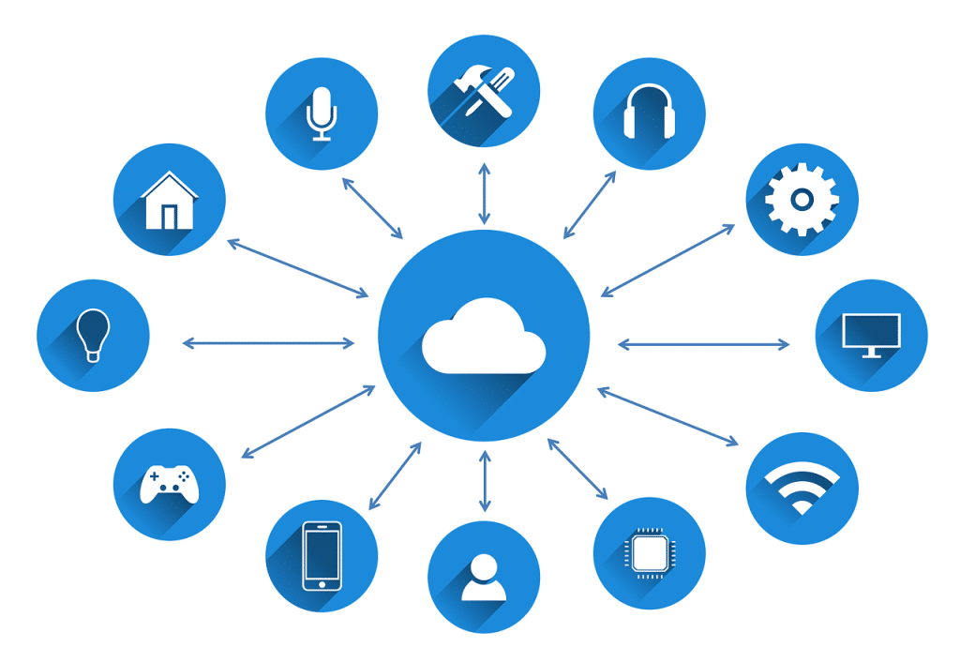

What cloud-computing services are available?
Cloud-computing services cover a vast range of options now, from the basics of storage, networking and processing power, through to natural language processing and artificial intelligence as well as standard office applications.
Pretty much any service that doesn't require you to be physically close to the computer hardware that you are using can now be delivered via the cloud – even quantum computing
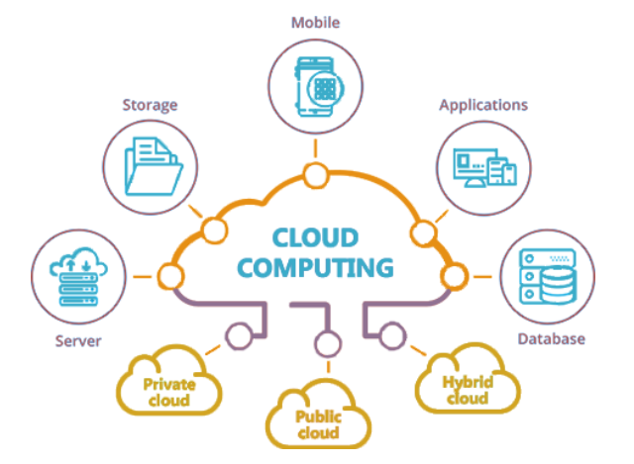

What are examples of cloud computing?
Cloud computing underpins a vast number of services. That includes consumer services like Gmail or the cloud backup of the photos on your smartphone, though to the services that allow large enterprises to host all their data and run all of their applications in the cloud. For example, Netflix relies on cloud-computing services to run its its video-streaming service and its other business systems, too.
Cloud computing is becoming the default option for many apps: software vendors are increasingly offering their applications as services over the internet rather than standalone products as they try to switch to a subscription model. However, there are potential downsides to cloud computing, in that it can also introduce new costs and new risks for companies using it.
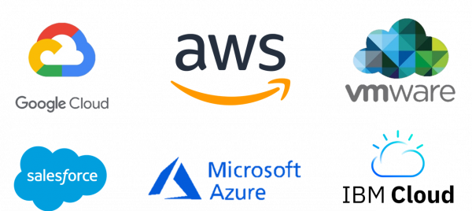

Why is it called cloud computing?
A fundamental concept behind cloud computing is that the location of the service, and many of the details such as the hardware or operating system on which it is running, are largely irrelevant to the user. It's with this in mind that the metaphor of the cloud was borrowed from old telecoms network schematics, in which the public telephone network (and later the internet) was often represented as a cloud to denote that the location didn't matter – it was just a cloud of stuff. This is an over-simplification of course; for many customers, location of their services and data remains a key issue
https://www.youtube.com/watch?v=cF_n9Yg4jwk&ab_channel=THEGOMYCODELIBRARY

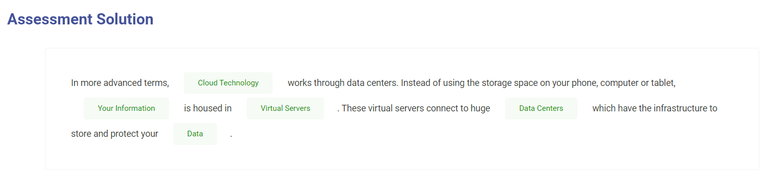

What are the core elements of cloud computing?

What are the core elements of cloud computing?

Cloud computing can be broken down into a number of different constituent elements, focusing on different parts of the technology stack and different use cases. Let's take a look at some of the best known in a bit more detail
- Software as a Service SaaS
- Infrastructure as a Service IaaS
- Platform as a Service PaaS

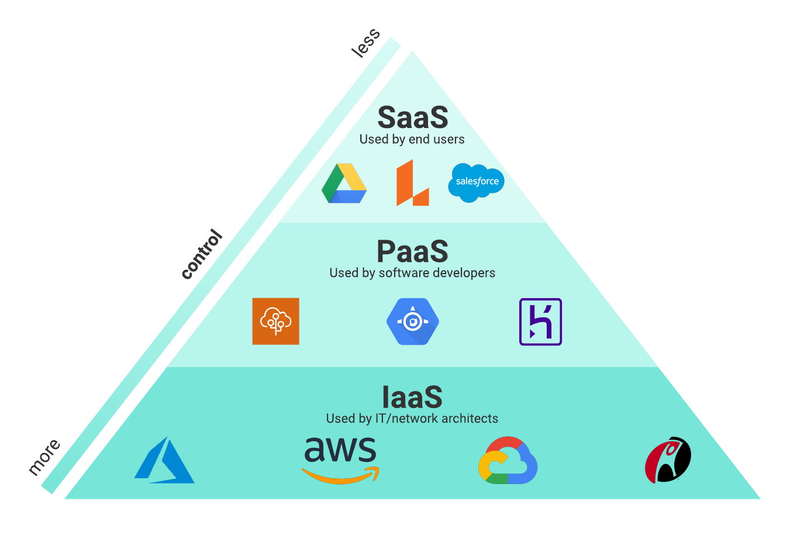

What is Software as a Service?
Software as a Service (SaaS) is the delivery of applications as a service, probably the version of cloud computing that most people are used to on a day-to-day basis. The underlying hardware and operating system is irrelevant to the end user, who will access the service via a web browser or app; it is often bought on a per-seat or per-user basis.
SaaS is the largest chunk of cloud spending simply because the variety of applications delivered via SaaS is huge, from CRM such as Salesforce, through to Microsoft's Office 365. And while the whole market is growing at a furious rate, it's the IaaS and PaaS segments that have consistently grown at much faster rates, according to analyst IDC: "This highlights the increasing reliance of enterprises on a cloud foundation built on cloud infrastructure, software-defined data, compute and governance solutions as a Service, and cloud-native platforms for application deployment for enterprise IT internal applications." IDC predicts that IaaS and PaaS will continue growing at a higher rate than the overall cloud market "as resilience, flexibility, and agility guide IT platform decisions".
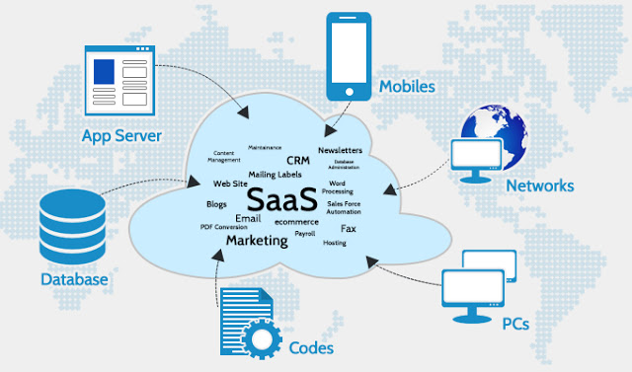

What is Infrastructure as a Service?
Infrastructure as a Service (IaaS) refers to the fundamental building blocks of computing that can be rented: physical or virtual servers, storage and networking. This is attractive to companies that want to build applications from the very ground up and want to control nearly all the elements themselves, but it does require firms to have the technical skills to be able to orchestrate services at that level.
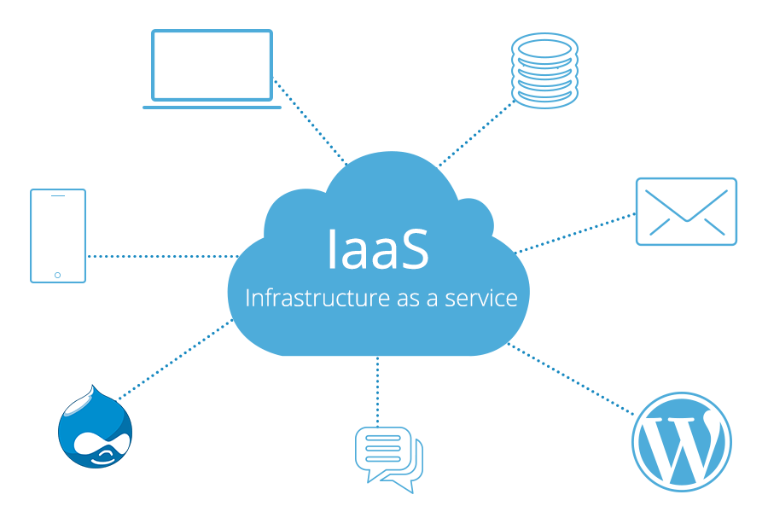
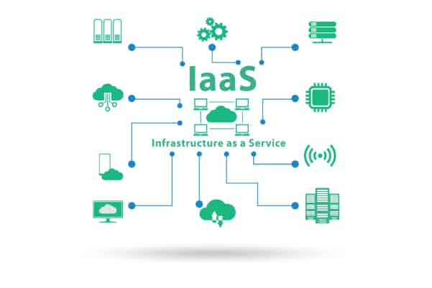

What is Platform as a Service?
Platform as a Service (PaaS) is the next layer up – as well as the underlying storage, networking, and virtual servers, this layer also includes the tools and software that developers need to build applications on top, which could include middleware, database management, operating systems, and development tools.
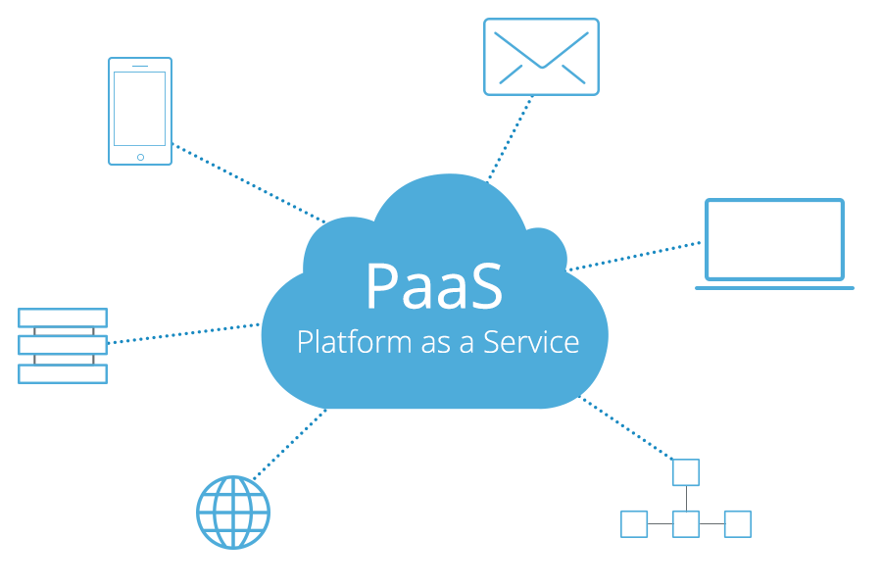
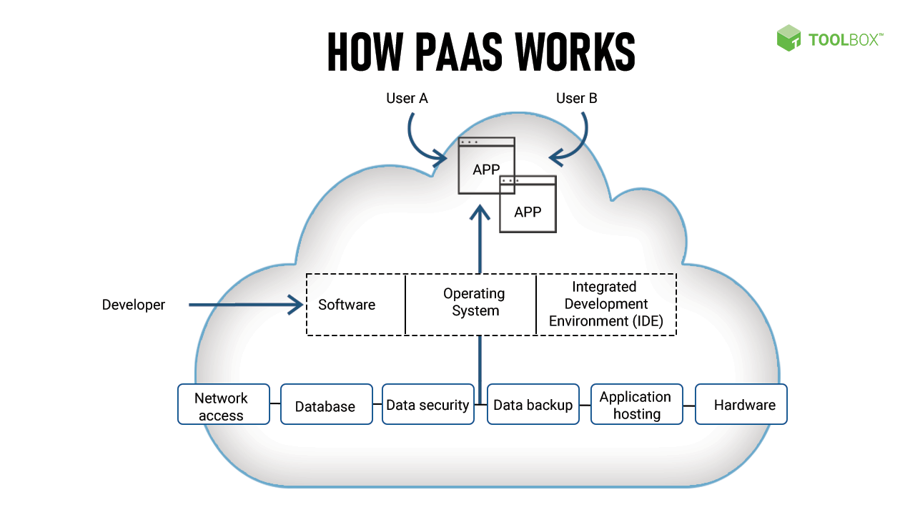

SaaS, IaaS and PaaS
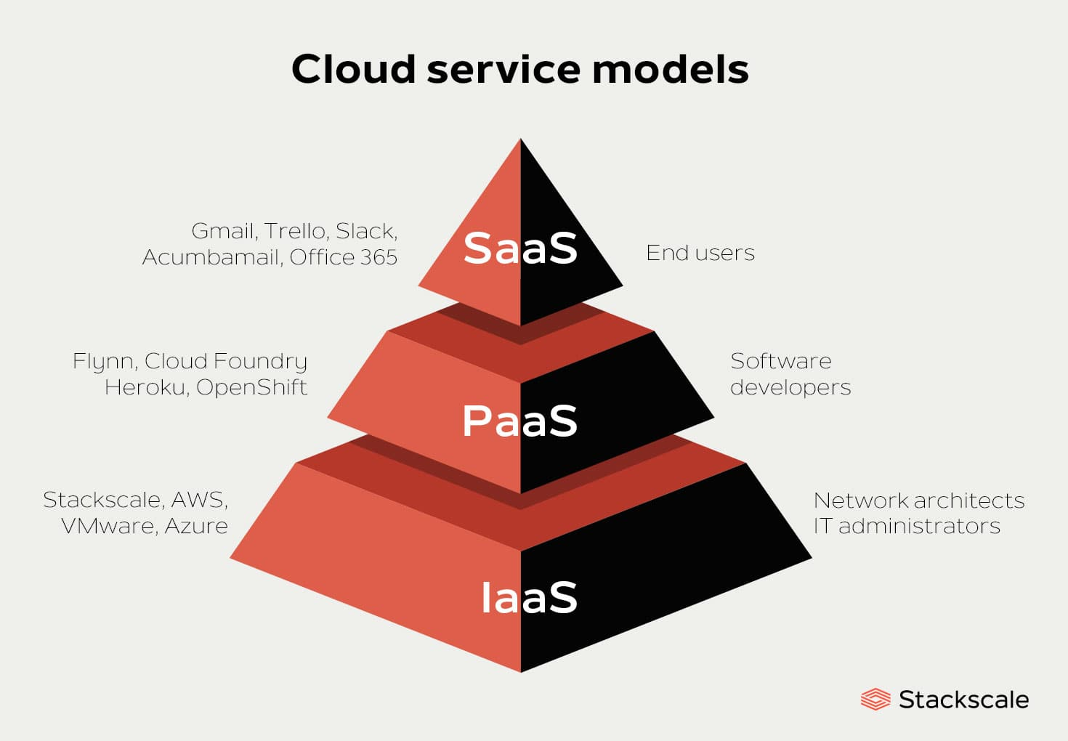
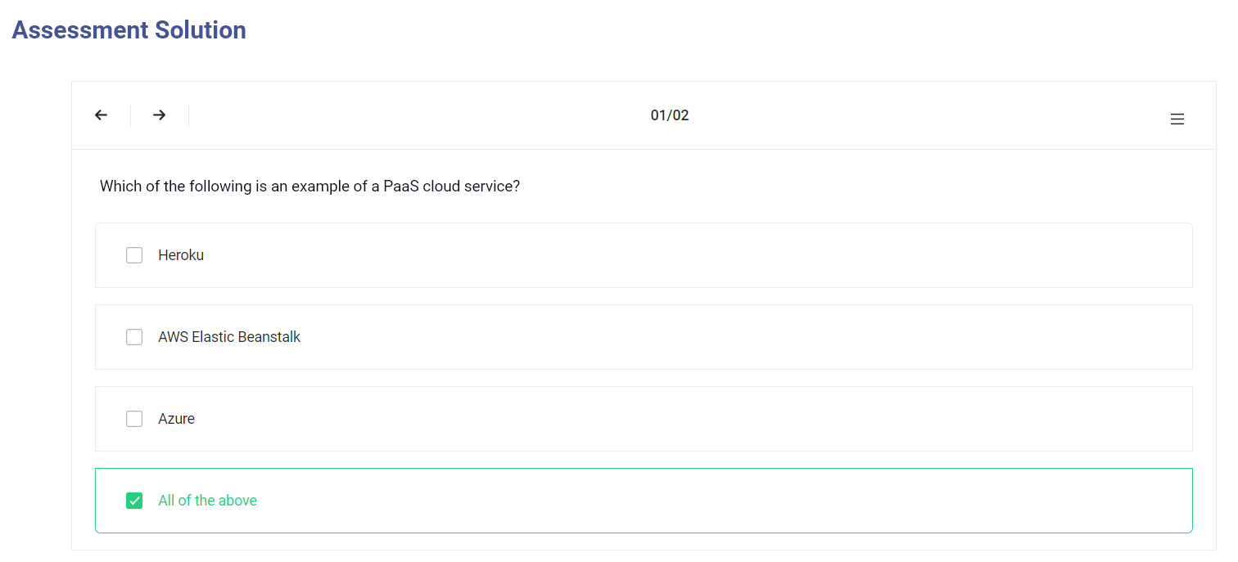
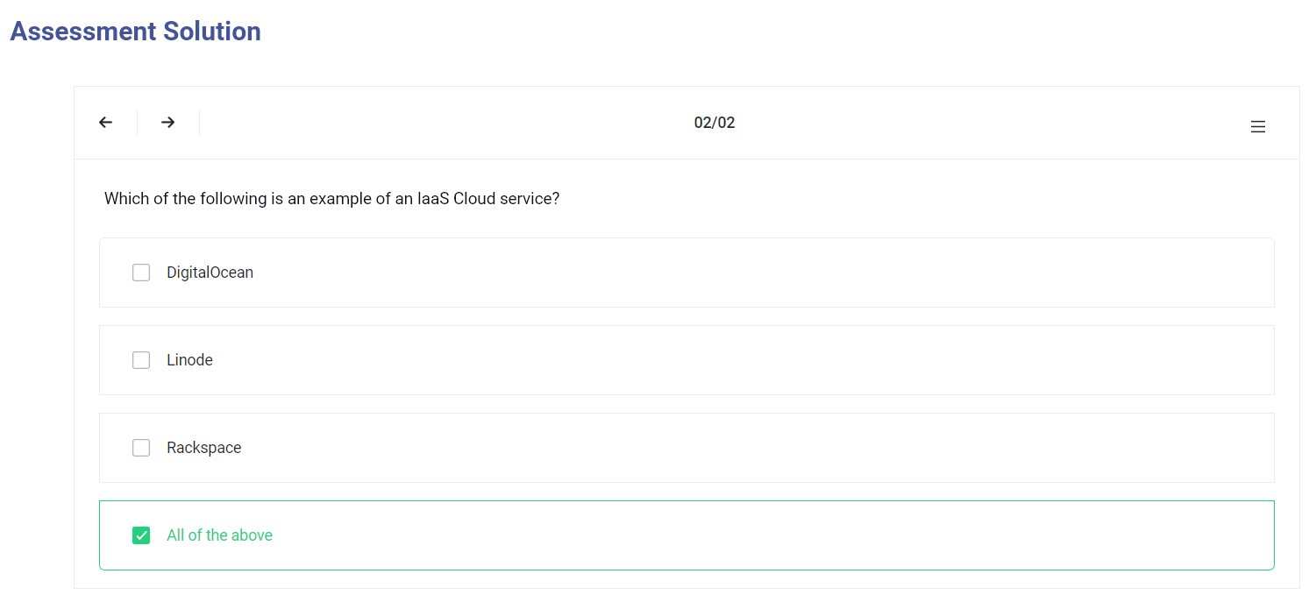

Benifits & disdvantages

What are the benefits of cloud computing?

The exact benefits will vary according to the type of cloud service being used but, fundamentally, using cloud services means companies not having to buy or maintain their own computing infrastructure.
No more buying servers, updating applications or operating systems, or decommissioning and disposing of hardware or software when it is out of date, as it is all taken care of by the supplier.
For commodity applications, such as email, it can make sense to switch to a cloud provider, rather than rely on in-house skills. A company that specializes in running and securing these services is likely to have better skills and more experienced staff than a small business could afford to hire, so cloud services may be able to deliver a more secure and efficient service to end users.
- 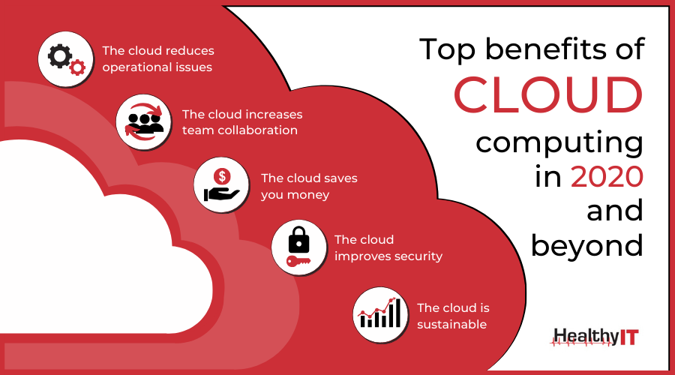

What are the benefits of cloud computing?
Using cloud services means companies can move faster on projects and test out concepts without lengthy procurement and big upfront costs, because firms only pay for the resources they consume.
This concept of business agility is often mentioned by cloud advocates as a key benefit.
The ability to spin up new services without the time and effort associated with traditional IT procurement should mean that it is easier to get going with new applications faster.
And if a new application turns out to be wildly popular, the elastic nature of the cloud means it is easier to scale it up fast.
- 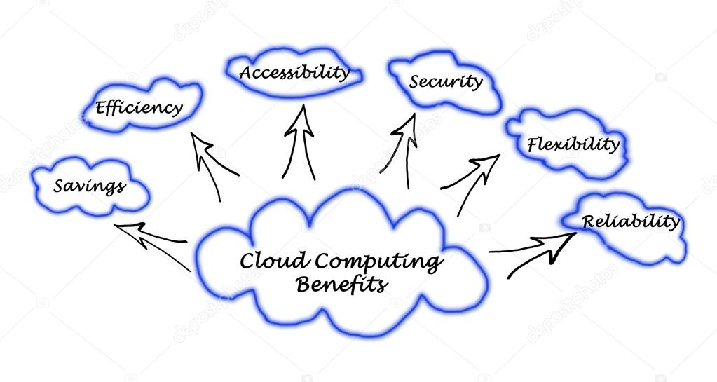

What are the disadvantages of cloud computing?
Cloud computing is not necessarily cheaper than other forms of computing, just as renting is not always cheaper than buying in the long term. If an application has a regular and predictable requirement for computing services it may be more economical to provide that service in-house.
Some companies may be reluctant to host sensitive data in a service that is also used by rivals. Moving to a SaaS application may also mean you are using the same applications as a rival, which might make it hard to create any competitive advantage if that application is core to your business.
- 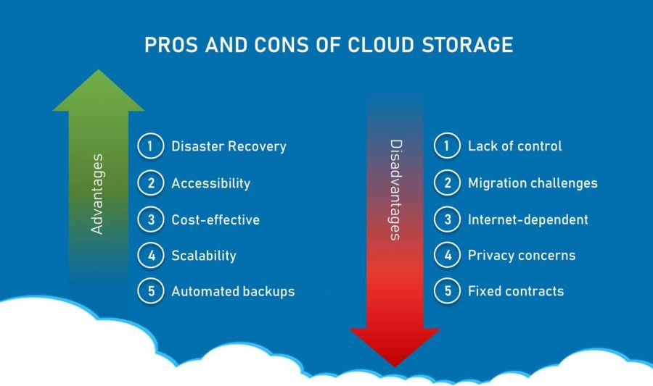

What are the disadvantages of cloud computing?
While it may be easy to start using a new cloud application, migrating existing data or apps to the cloud might be much more complicated and expensive. And it seems there is now something of a shortage in cloud skills, with staff with DevOps and multi-cloud monitoring and management knowledge in particularly short supply.
In one report, a significant proportion of experienced cloud users said they thought upfront migration costs ultimately outweigh the long-term savings created by IaaS.
And of course, you can only access your applications if you have an internet connection.
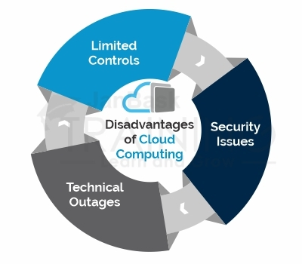

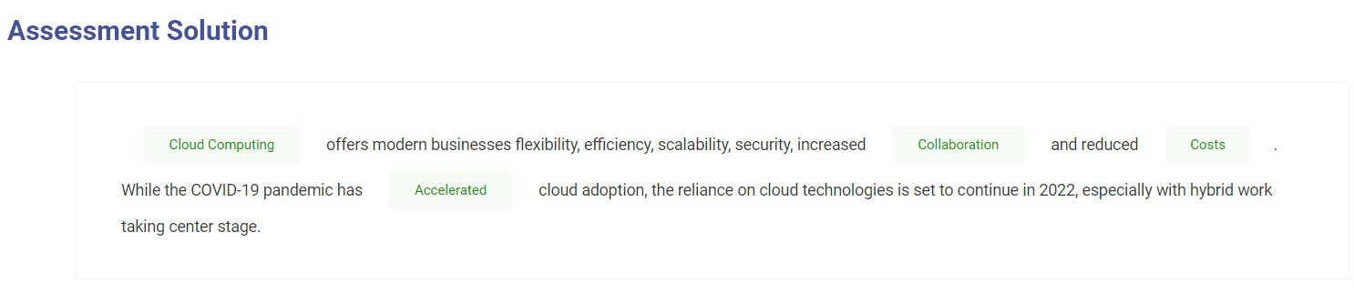

Cloud Security

What about cloud-computing security?
Many companies remain concerned about the security of cloud services, although breaches of security are rare. How secure you consider cloud computing to be will largely depend on how secure your existing systems are.
In-house systems managed by a team with many other things to worry about are likely to be more leaky than systems monitored by a cloud provider's engineers dedicated to protecting that infrastructure.
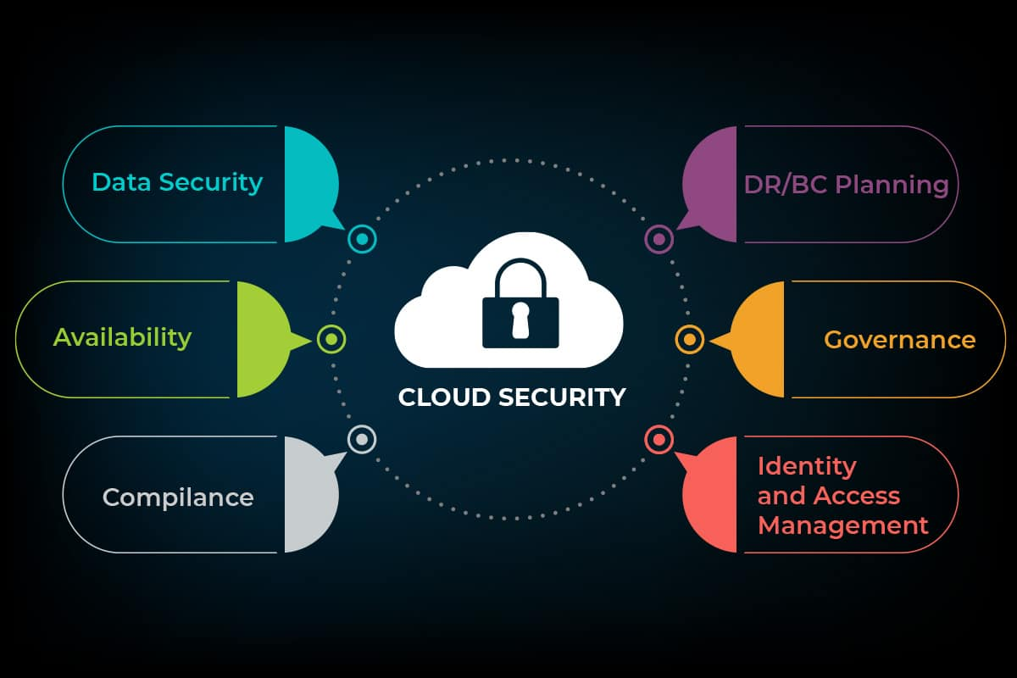
Let's see now the differents types of Cloud.

What is public cloud?
Public cloud is the classic cloud-computing model, where users can access a large pool of computing power over the internet (whether that is IaaS, PaaS, or SaaS). One of the significant benefits here is the ability to rapidly scale a service.
The cloud-computing suppliers have vast amounts of computing power, which they share out between a large number of customers – the 'multi-tenant' architecture.
Their huge scale means they have enough spare capacity that they can easily cope if any particular customer needs more resources, which is why it is often used for less-sensitive applications that demand a varying amount of resources.
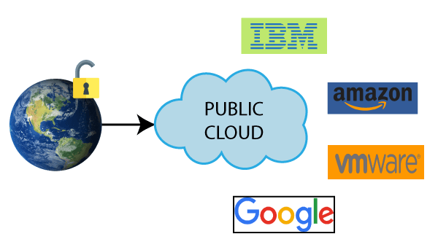

What is private cloud?
Private cloud allows organizations to benefit from some of the advantages of public cloud – but without the concerns about relinquishing control over data and services, because it is tucked away behind the corporate firewall.
Companies can control exactly where their data is being held and can build the infrastructure in a way they want – largely for IaaS or PaaS projects – to give developers access to a pool of computing power that scales on-demand without putting security at risk.
However, that additional security comes at a cost, as few companies will have the scale of AWS, Microsoft or Google, which means they will not be able to create the same economies of scale. Still, for companies that require additional security, private cloud might be a useful stepping stone, helping them to understand cloud services or rebuild internal applications for the cloud, before shifting them into the public cloud.
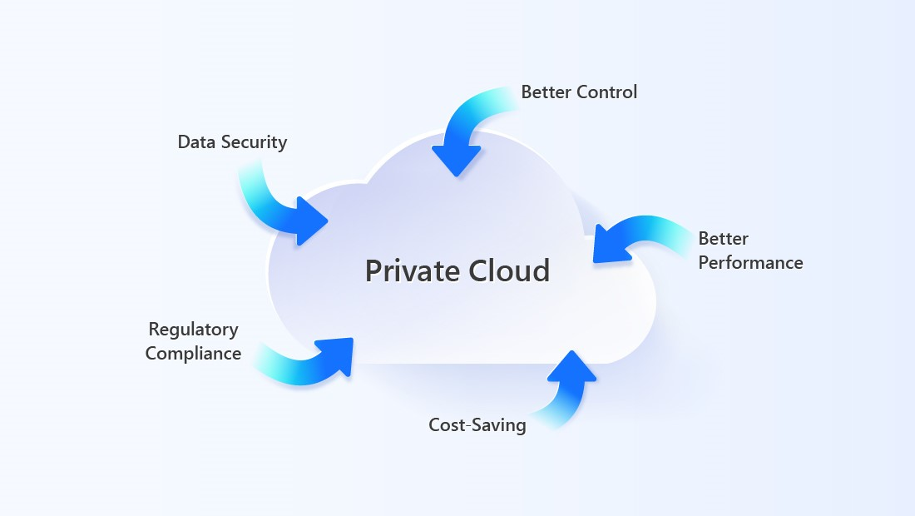

What is hybrid cloud?
Hybrid cloud is perhaps where everyone is in reality: a bit of this, a bit of that. Some data in the public cloud, some projects in private cloud, multiple vendors and different levels of cloud usage.
- Infographic: Companies are turning to hybrid cloud to save money
- What does 'hybrid cloud' mean? It depends on whom you ask
- Managing the multi-cloud: It's complicated
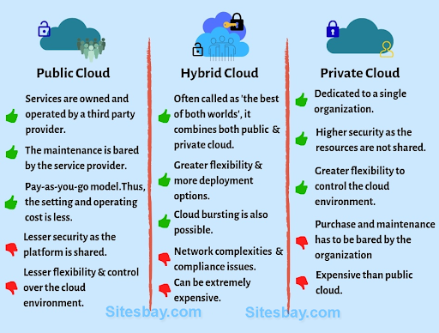
https://www.zdnet.com/article/infographic-companies-are-turning-to-hybrid-cloud-to-save-money/
https://www.zdnet.com/article/what-does-hybrid-cloud-mean-it-depends-on-whom-you-ask/
https://www.zdnet.com/article/beyond-cloud-theres-multi-cloud-beyond-multi-cloud-theres-managing-it-all/

